Skin Rejuvenation Therapy

Skin rejuvenation therapy gives you the answer
to your skin problems safely and effectively

Face & Body Therapies Ulladulla is proud to offer the latest
breakthrough in Skin Rejuvenation Therapy, using the next
generation in pulsed light technology. Energist Ultra VPL, an
exciting non-invasive treatment for benign skin conditions,
such as pigmentation, sun damage, facial redness,
broken capillaries, acne scarring, enlarged pores and fine lines.

Ultra’s Variable Pulsed Light (VPL) works by penetrating the
epidermis, or the top layer of the skin, with a specific wavelength
of light that targets the dermis where melanin, hemoglobin and
collagen reside.

The advanced computer installed in the Energist Ultra VPL, operated by highly trained technicians, regulates the wavelengths of light being emitted, administering the correct wavelength and exposure to the conditions being treated, allowing for a safe, effective treatment without causing damage to the surrounding tissue.

PIGMENTATION
Photo rejuvenation with VPL provides superior results for many skin concerns including pigment marks caused by sun or age; freckles and generalised facial redness.

Pigmented lesions may be present on you skin due to a number of reasons; including:
- Genetics, such as in the case of freckling
- Photo damage from UV rays, resulting in sun spots.
- Melasma may be present as a result of hormonal changes, pregnancy or the contraceptive pill.

VPL will effectively remove or significantly lighten pigmentation as the skin’s melanin absorbs the light energy, transferring into heat energy to destroy the melanin containing skin cell.

Initially the treated pigmentation will appear darker, however within approximately 2-4 weeks this will diminish and a clearer complexion will become visible. Multiple sessions may be required to produce the desired result with maintenance treatments often necessary.

In cases of excessive pigmentation in the skin, photons from the light emitted from the VPL are absorbed by the pigment (melanin) and converted into heat. Where the pigmentation is denser, there is more heating and this damages both the existing pigment and the structures that generate excessive pigment (melanocytes).

The body recognises the de-natured melanin as waste and begins to expel it from the body, through the cellular system, rapidly migrating it to the surface of the skin. This process can leave the skin looking a little ‘dirty’ until the expelled cells are desquamated (sloughed off), usually at around 10 days post treatment.

ACNE SCARRING
Energist Ultra improves both active acne and acne scarring by destroying the bacteria that causes the infection. Acne is healed significantly following a course of treatments and skin texture and tone is improved as the Energist Ultra initiates further collagen production.

CAPILLARIES, ROSACEA, CHERRY SPOTS
These are conditions where small veins become visible on the skin’s surface. With the Energist Ultra, light energy is absorbed by the blood vessels that make up these imperfections. This absorption process breaks down the vessel walls and allows the body to recognise this as waste and removes them through the lymphatic system. The Energist Ultra is very effective for these conditions with a series of treatments bringing about a lessening of facial redness.

OPEN PORES AND FINE LINES
Collagen is the substance in our bodies that keeps our skin looking youthful and smooth. As we age, our bodies naturally produce less and less collagen, resulting in the appearance of fine lines and wrinkles. The light from the Energist Ultra stimulates cells in the body to produce more collagen resulting in a smoother texture, smaller pore size and reduced fine lines and wrinkles.

Visible light is absorbed in the microscopic capillaries in the skins surface and raises the temperature enough to stimulate the natural repair system, including fibroblasts that create collagen. This process re-moulds, thickens and tightens the collagen layer. Diminishing fine lines and open pores.

Superseding traditional laser treatments, by leaving the surface layer of the skin undamaged, the recovery or ‘down time’ is such that you are able to return to your normal activities immediately.

After a full consultation and case analysis with highly trained staff, a comprehensive treatment program is developed to match your individual needs, detailing all of your treatment requirements, as well as a detailed pre and post treatment program to ensure that you achieve the optimum results from your treatments.
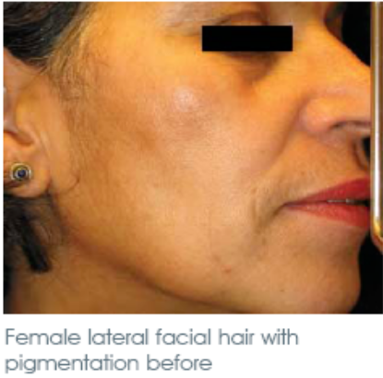
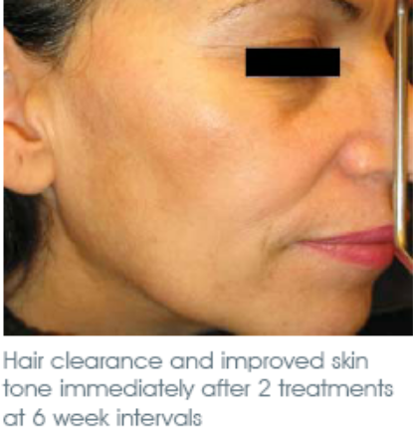
Start Looking
Younger Today!

Pick up the phone
and call

4454 3521

Skin Rejuvenation Therapies are our specialty, whatever your concerns we have the advanced knowledge, products and treatments to make you look and feel spectacular.
Real Results at Face & Body Therapies Ulladulla.



Exclusive to Ulladulla’s No. 1 Beauty and Massage Salon

